Nom : ……………………………. Date : …………………………….
CP

Lecture
Fiche
L1

Ce1

Mots fléchés [a]

 |  |  |  |  |  |  |  | 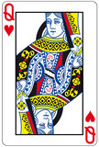
 |  |  | 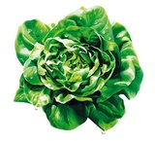
 | 
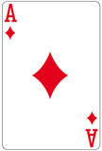
 |  |  |  | 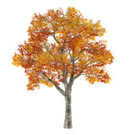
 |  |  |  |  |  |  |  |  | 
 |  | 

 |  |  |  | 
http://www.i-profs.fr

Nom : ……………………………. Date : …………………………….
CP

Lecture
Fiche
L1

Mots fléchés [a]

dame – salade – ananas – carte– tomate – âne – banane – tasse – maïs – arbre - chat

http://www.i-profs.fr

Nom : ……………………………. Date : …………………………….
CP

Lecture
Fiche
L1

Ce1

Mots fléchés [a]

 |  |  |  |  | S | A | L | A | D | E
 |  |  |  |  |  | N |  |  | A
 |  | C | A | R | T | E |  |  | M
 |  | H |  |  |  |  |  |  | E
 |  | A
 |  | T | O | M | A | T | E
 |  |  |  |  | R |  |  |  | A
 |  |  |  |  | B | A | N | A | N | E
 |  |  |  |  | R |  |  |  | A
 | T | A | S | S | E |  |  |  | N
 |  |  |  |  |  |  |  |  | A
http://www.i-profs.fr |  |  |  |  |  | M | A | I | S

